**23CSE111**

**LAB MANUAL**



**Department of CSE**

**Amrita School of Engineering**

**Amrita Vishwa Vidyapeetham, Amaravati Campus**

**Verified By :- Name: B.Syam Sunder**

**Roll No: AV.SC.U4CSE24023**

|  |  |  |  |  |
| --- | --- | --- | --- | --- |
| S.NO | Programs | Date | Pg:No | Signature |
| 1 | 1. Download and Install Java Software. 2. Write a java program to print message “Welcome to java programming”. 3. Write a java program that prints name,roll number,section of a student. |  |  |  |
|  |  |  |  |  |
|  |  |  |  |  |
|  |  |  |  |  |
|  |  |  |  |  |
|  |  |  |  |  |
|  |  |  |  |  |
|  |  |  |  |  |

Week 1:-

# Program-1:-

## Aim:-Download and Instal the Java Software Procedure Step-1:- Type Java download in search

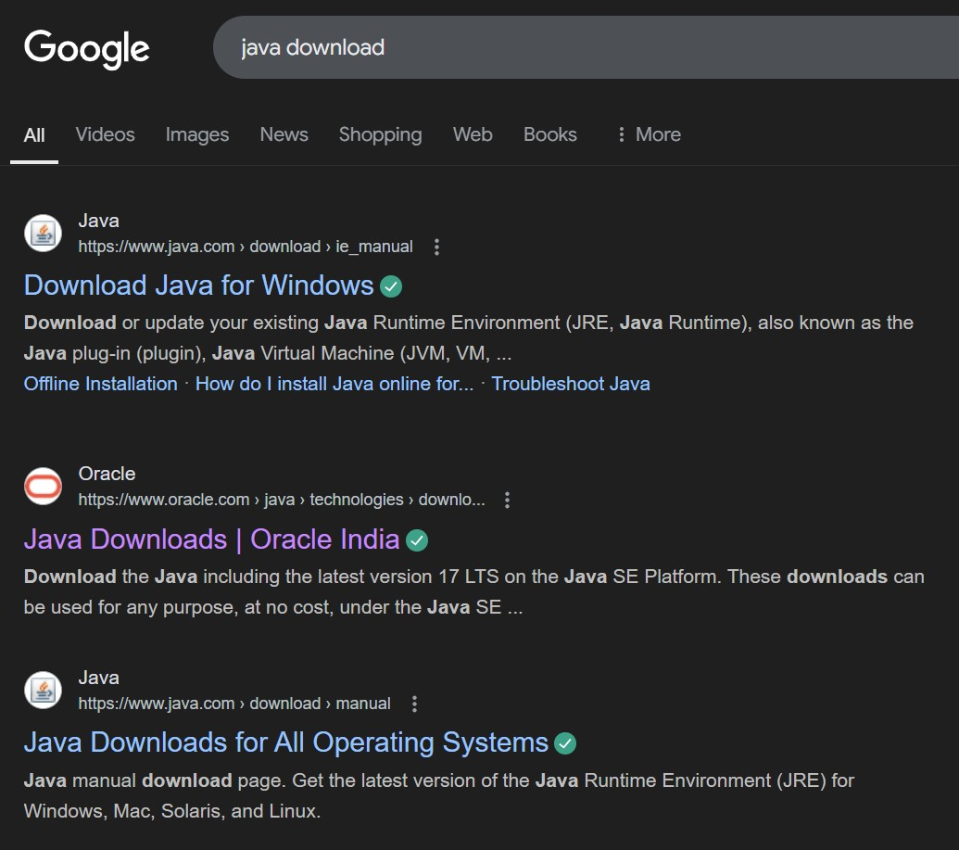

## Step-2:-click on oracle java download and enter into oracle website

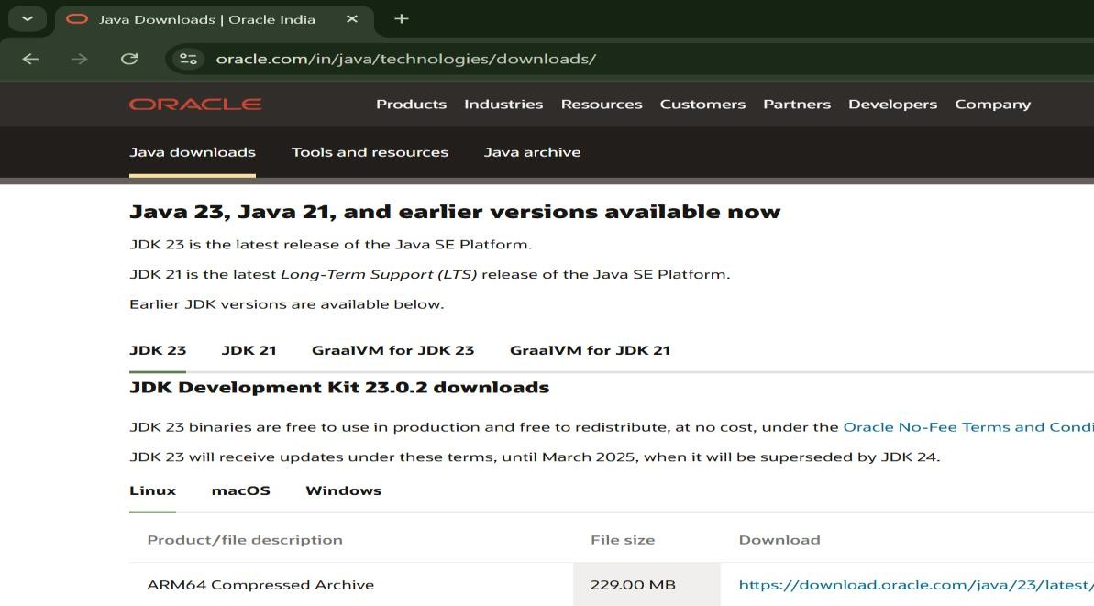

## Step-3:-click on JDK21 and click on windows and later click on x64 instalier link to download

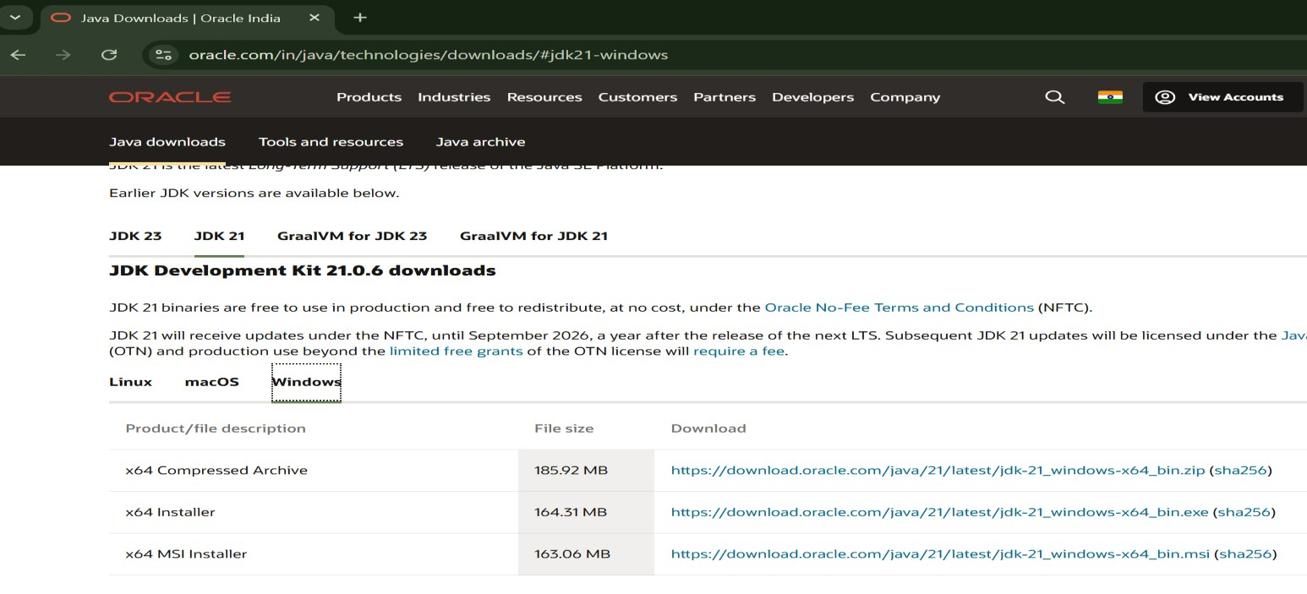

## Step-4:-After completing download click on it’s file and then give permission to install

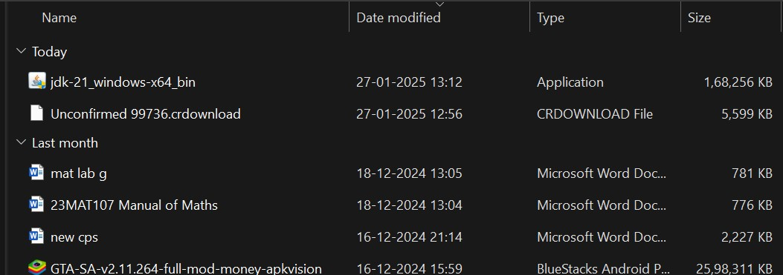

Step-5:-Then go to (This pc) in that click (windows{c}) in that click (Program files) in that click (Java) in that click (jdk-21) in that click (bin)

## Step-6:-Select and copy path of opening the file and then press windows and search System Environmental

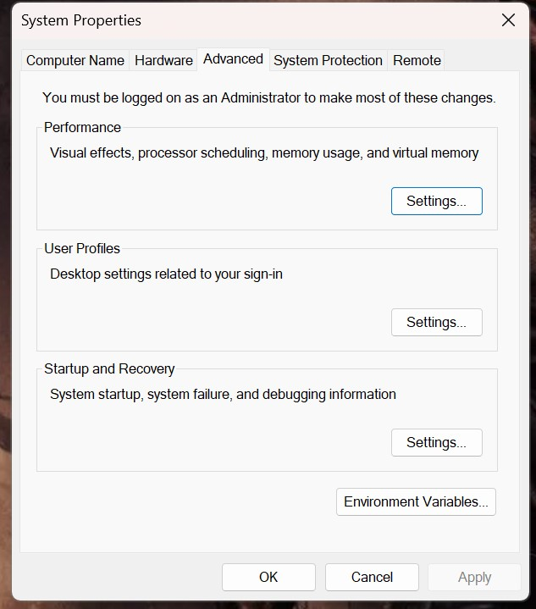

Step-7:-After opening Environment variables then past path of opening file in user variable and click on ok

## Step-8:-To verify version open CMD and type java --version

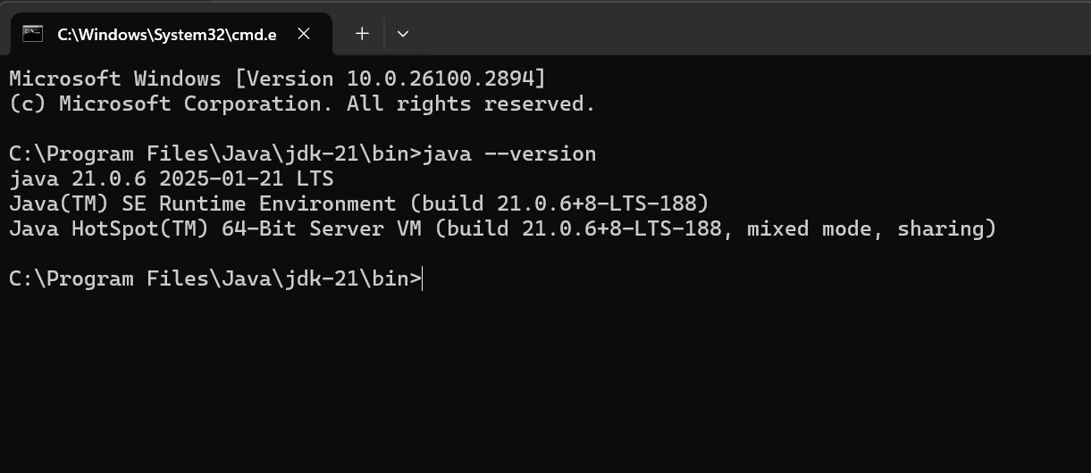

**Program : 2**

## Aim:-write a java program to print[welcome to java programming Input:-

class ex_1{

public static void main(String[] args){

System.out.println("welcome to java programming");

}

}

## Output:-



### Program : 3

Aim:-write a java program that prints name, roll no, section of the student Input:-

class ex_2{

public static void main(String[] args){

System.out.println("Name: B.Syam Sunder");

System.out.println("Class: CSE A");

System.out.println("Roll No: 24023");

}

}

### Output:-

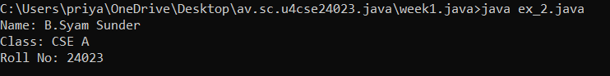

***Week-2***

Program-1:

Aim: to write a java program to find area of rectangle

Input:

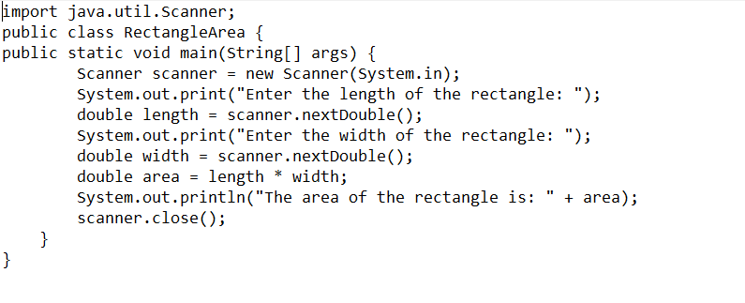

Output:

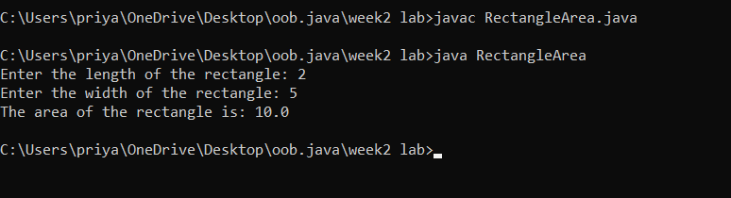

Errors:

|  |  |  |
| --- | --- | --- |
| **Error Type** | **Description** | **Correction** |
| **Syntax Error** | Unclosed string literal(“ missing) | Ensure all strings are properly enclosed in double quotes (") |
| **Runtime Error** | Dividing by zero when calculating an aspect ratio | Check for zero before division (if (width != 0) { ... }) |

Program-2

2.write a java program to convert the temperature from celcius to farhienheat:

Program:

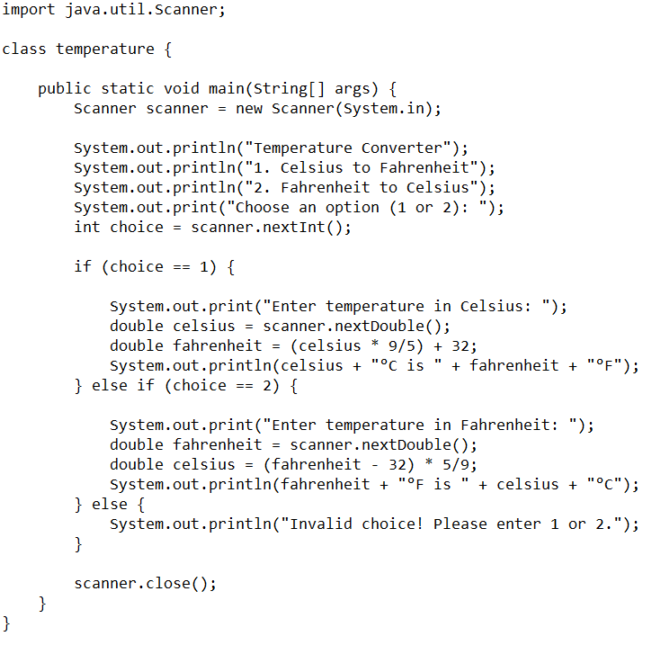

Output:

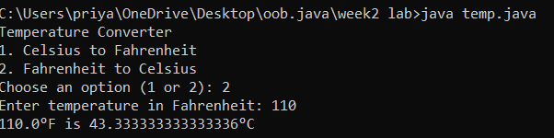

Error:

|  |  |  |
| --- | --- | --- |
| **Error Type** | **Description** | **Correction** |
| **Syntax Error** | Forgot to write ; (semicolon) | Ensure every statement ends with a semicolon (;) |
| **Runtime Error** | Dividing by zero when calculating an aspect ratio | Check for zero before division (if (width != 0) { ... }) |
| **Variable Declaration Error** | Wrong variable declaration | Use correct data types and proper syntax |

Program-3

3.write a java program to cacluate the simple intrest

Program:

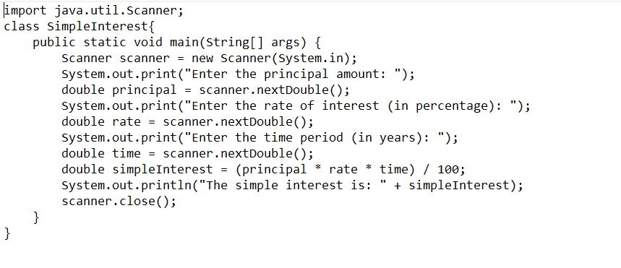

Output:

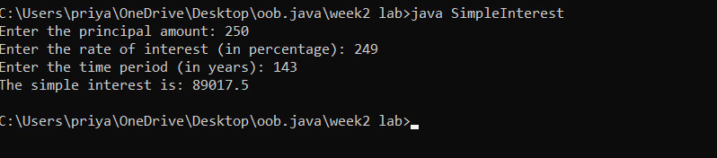

Error:

|  |  |  |  |  |  |
| --- | --- | --- | --- | --- | --- |
|  | |  | |  | |
|  | |  | |  | |
|  | |  | |  | |
| **Error Type** | **Description** | | **Correction** | |
| **Syntax Error** | Missing semicolon (;) after System.out.println() | | Add ; at the end of System.out.println() statements | |
| **Data Type Error** | int used instead of double for time (t) | | Change int t = read.nextInt(); to double t = read.nextDouble(); | |
| **Type Mismatch** | int r = read.nextDouble(); (assigning double to int) | | Change int r to double r for correct data type | |

Program-4

Write a java program to find the largest of three numbers using terinary operator

Program:

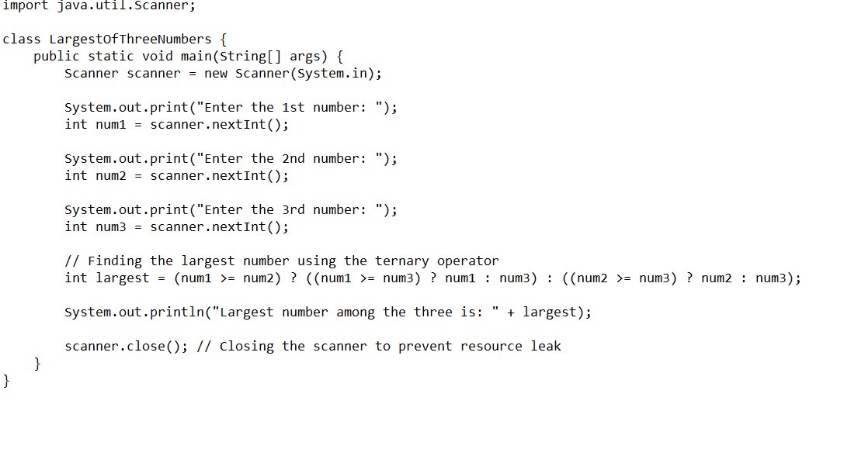

Output:

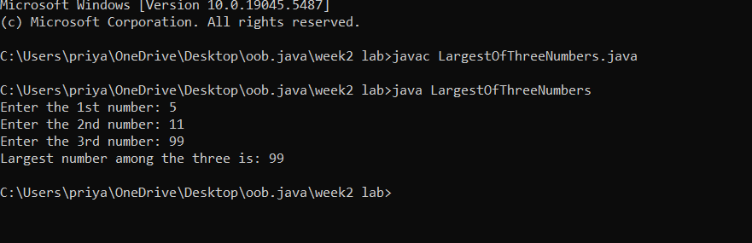

Error:

|  |  |  |
| --- | --- | --- |
| **Error Type** | **Description** | **Correction** |
| **Syntax Error** | Missing space in output: "Largest Number of 3 numbers is" + largest | Change to "Largest Number of 3 numbers is " + largest (add space before largest) |
| **Logical Error** | No read.close(); to free resources | Add read.close(); at the end of the program |
| **Input Handling Issue** | No prompt for invalid input (e.g., non-integer values) | Add input validation using if (read.hasNextInt()) before reading values |

Program-5

5.Write a java program to find the factorial of a number

Program:

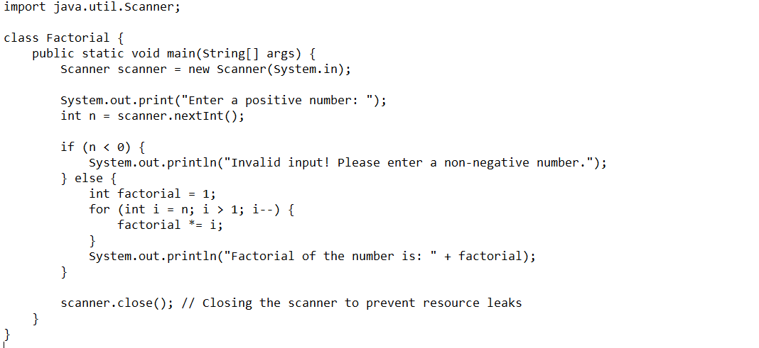

Output:

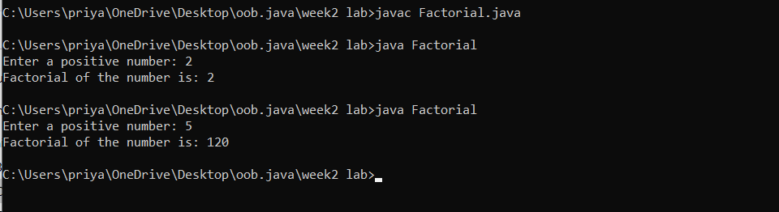

Error:

|  |  |  |
| --- | --- | --- |
| **Error Type** | **Description** | **Correction** |
| **Syntax Error** | do keyword mistakenly placed before for loop | Remove do before for(int i=n; i>=1; i--) |
| **Logical Error** | if(n<0) check comes after the factorial calculation | Move if(n<0) check before the loop to prevent calculation |
| **Resource Leak** | Scanner not closed | Add read.close(); at the end of the program |

Week-3

1. Create the java program for the cars with constructor and methods

Program:

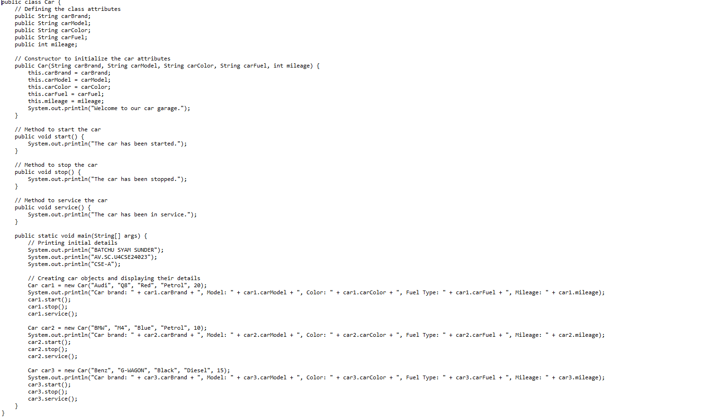

Output:

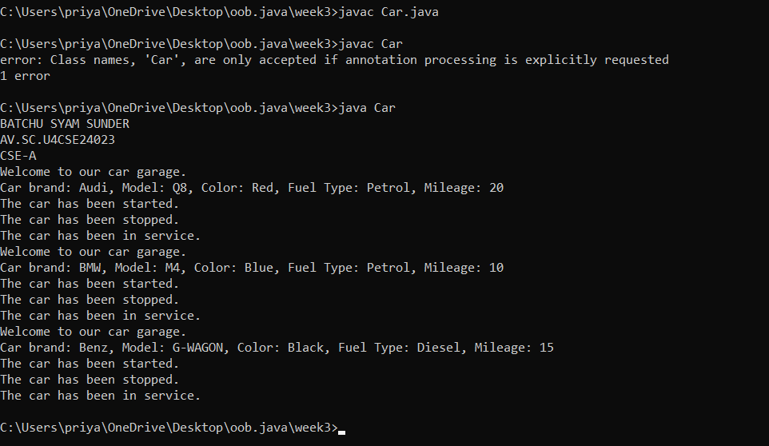

Class diagram:

**Error:**

|  |  |  |
| --- | --- | --- |
| **Error Type** | **Incorrect Code** | **Corrected Code** |
| **Class Naming Issue** | **class main{** | **class Main{** |
| **Incorrect Object Description** | **"Our first car is "+car2.car_brand;** | **"Our second car is "+car2.car_brand;** |

Program-2

1. Create the java program to withdraw and deposit money in the bank account.

Program:

Class diagram:

Program:

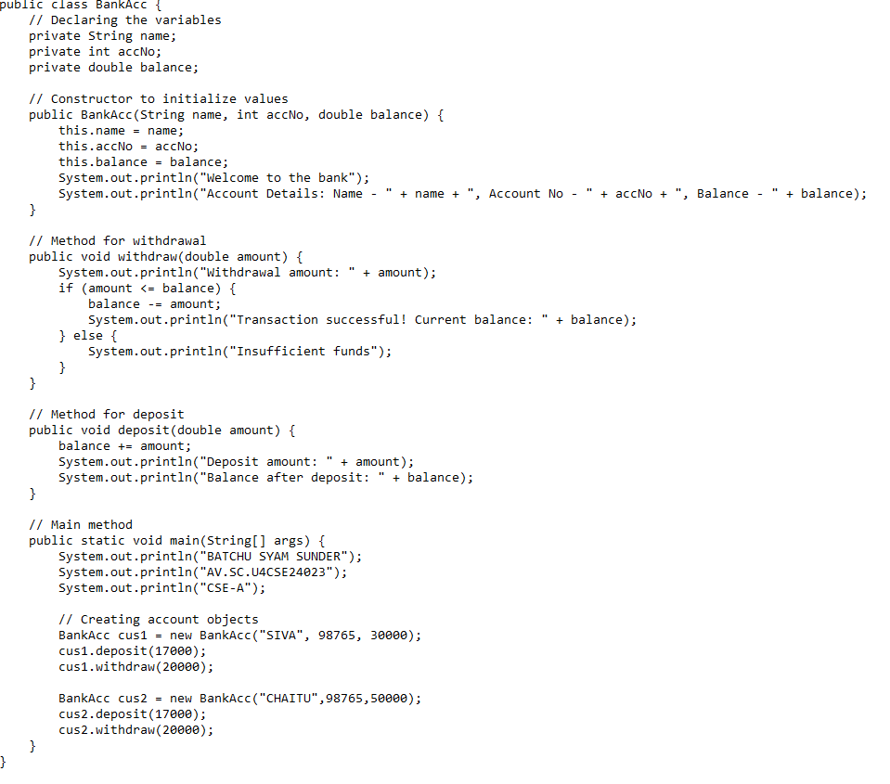Output: 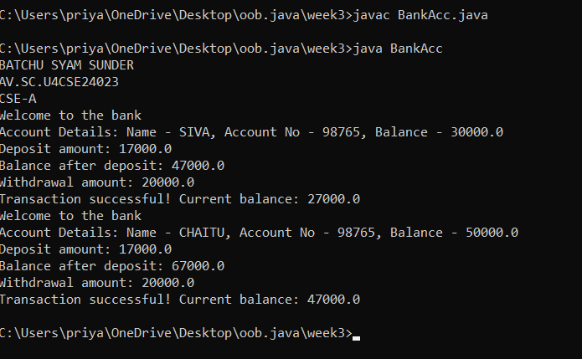

**Error:**

|  |  |  |
| --- | --- | --- |
| **Error Type** | **Incorrect Code** | **Corrected code** |
| **Class Name Capitalization** | class Bankaccunt | class BankAccount (Java follows PascalCase for class names) |
| **Object Naming Issue** | BankAccount person-1 (hyphen is not allowed) | BankAccount person1 |
| **Missing Semicolon** | System.out.println ("Balance is "+ person-1.deposit (50,000)) | System.out.println ("Balance is "+ person1.deposit (50000)); (semicolon added) |

Week-4

1. Create the java program for the books by using the constructor and display its details using methods.

Program

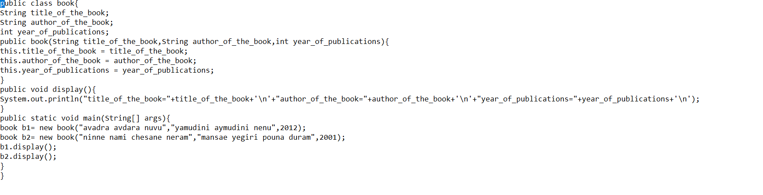

Output:

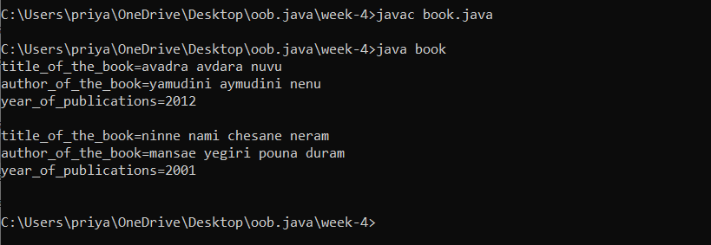

**Errors:**

|  |  |  |  |  |
| --- | --- | --- | --- | --- |
| **Error Type** | |  | | --- | | **Incorrect Code** |  |  | | --- | |  | | **Corrected Code** |
| **Class Name Capitalization** | public class book | public class Book (Java follows PascalCase for class names) |
| **Constructor Name Mismatch** | new book(...) | new Book(...) (Constructor name must match class name) |
|  |  |  |
|  |  |  |

1. Program to explain the final and the static variables.

Program:

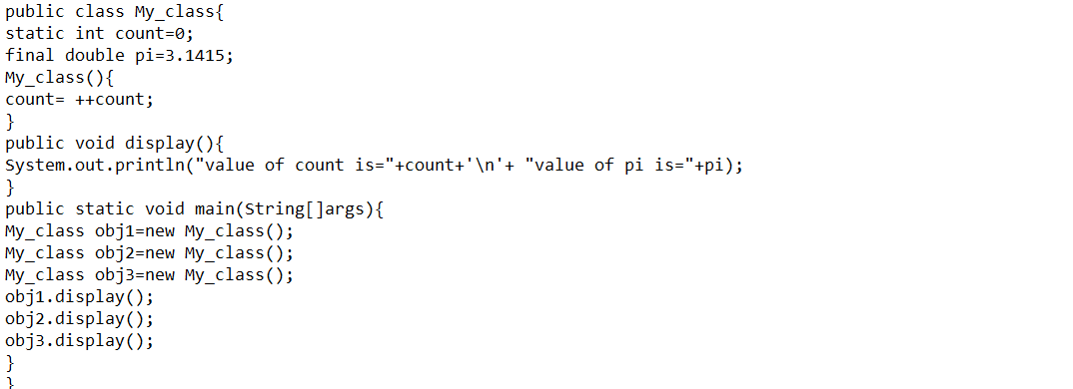

Output:

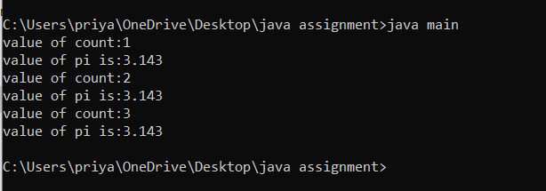

**Error:**

|  |  |  |
| --- | --- | --- |
| **Error Type** | **Incorrect Code** | **Corrected Code** |
| **Attempt to Modify final Variable** | pi = 3.14; (if added inside the constructor or method) | Remove this line (final variables cannot be reassigned) |
| **Incorrect Class Name** | public class Myclass | public class MyClass (Java follows PascalCase for class names) |

**Week-5**

**Program 1:**

**Aim: Create a calculator using the operations including addition using subtraction, multiplication and division using multilateral inheritance and display the desired output.**

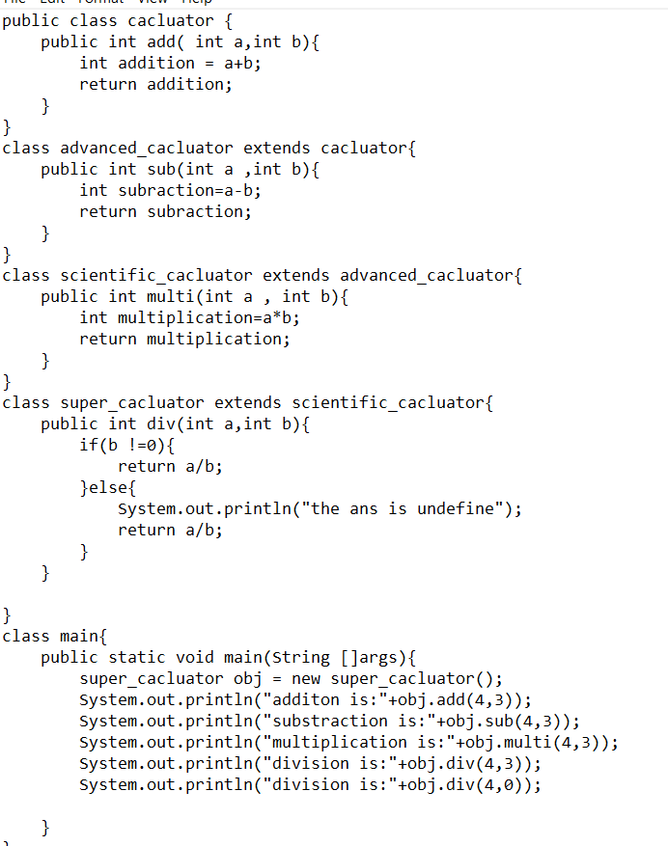

Output:

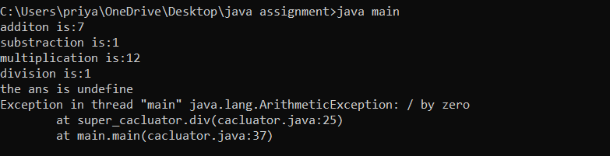

**Error table:**

|  |  |  |  |
| --- | --- | --- | --- |
| **S.No** | **Error Type** | **Reason for error** | **Rectification** |
| **1.** | Constructive error | Invalid method name declared | Created class name |
| **2.** | Syntax error | Haven’t included ‘;’ | Added ‘;’ |
|  |  |  |  |

**Program-2:**

**Aim:**

A vehicle rental company wants to develop a system that maintains

Information about different types of vehicles available for rent

The Company rents out cars, bikes and truck and they need a program to

Store details about each vehicle, such as brand and speed

Cars should have an additional property: number of doors

Bikes should have a property indicating whether they have gears or not

The system should also include a function to display details about each vehicle

And indicate when a vehicle is starting.

**Program:**

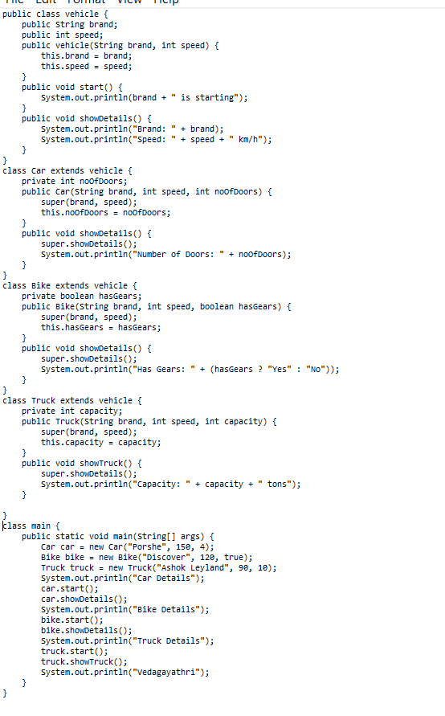

\

**Output**:

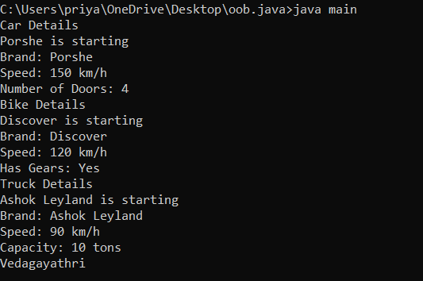

Error table:

|  |  |  |  |  |
| --- | --- | --- | --- | --- |
| S No | ErrorType | Cause | Rectification |  |
| 1 | SyntaxError | Semicolon missing | Added ; |  |
|  |  |  |  |  |